Computer Network & Communication

Network Media

- refers to the communication channels used to interconnect nodes on a computer network. Typical example es of network media include copper coaxial cable, copper twisted pair cables and fiber-optic cables used in wired networks, and radio waves used in wireless data communications networks.

- Refers to provide the pathway over which data can be transmitted.

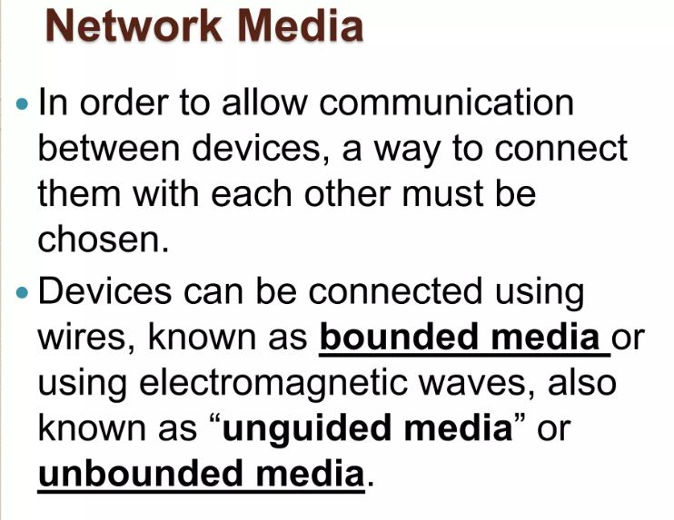

**Wired Media** (Bounded , Guided network)- device that can be connected by wires.

**Wireless Media** ( Unbounded, Unguided media)-Using electromagnetic wave, also known as Unbounded or unguided.

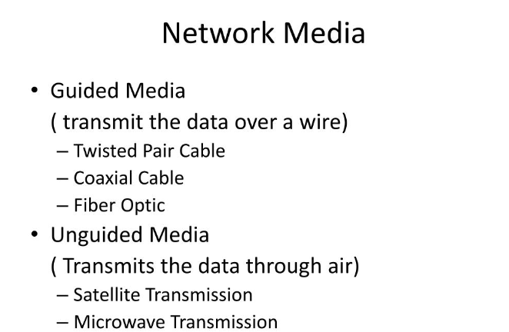

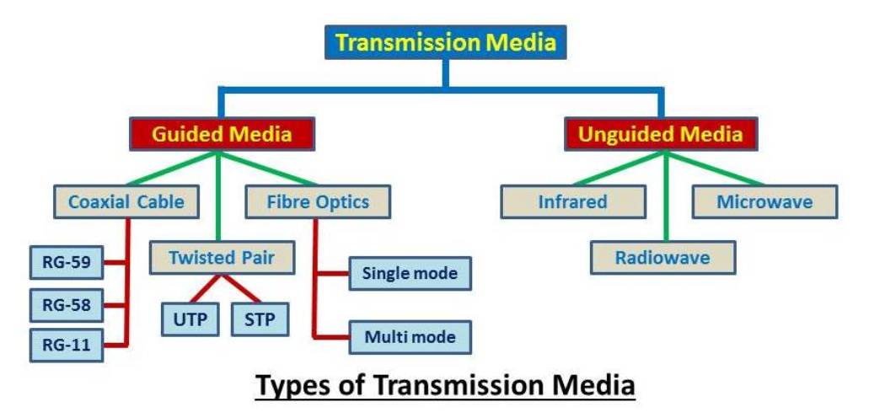

**Ethernet cabling used in networking**

* Twisted-Pair cable
* Coaxial cable
* Fiber Optic

Wired Networks

Wired network

* A wired network uses cables to connect devices, such as laptop or desktop computers, to the Internet or another network. A wired network has some disadvantages when compared to a wireless network. The biggest disadvantage is that your device is tethered to a router.

` Ethernet Cable used in Networking

a. Coaxial Cable

- Coaxial cables are used as transmission lines for radio frequency, video and data signals. They have traditionally been used as feed lines to connect radio transmitters and receivers with antennas, internet connections, digital audio and cable television signals.

What is the speed and bandwidth of coaxial cable?

It is quite normal to achieve a download speed of 100 to 1000 Mbps (12.5 to 62.5 MB) with optical fibre. And with coax we now

reach speeds between 50 and 1000 Mbps (6.25 to 62.5 MB). So internet by coax has since become as fast as by optical fibre.

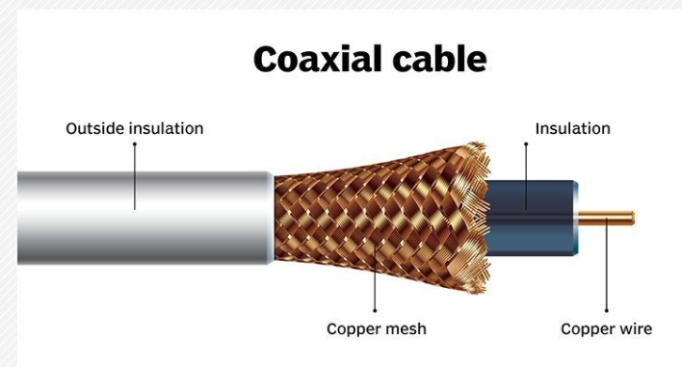

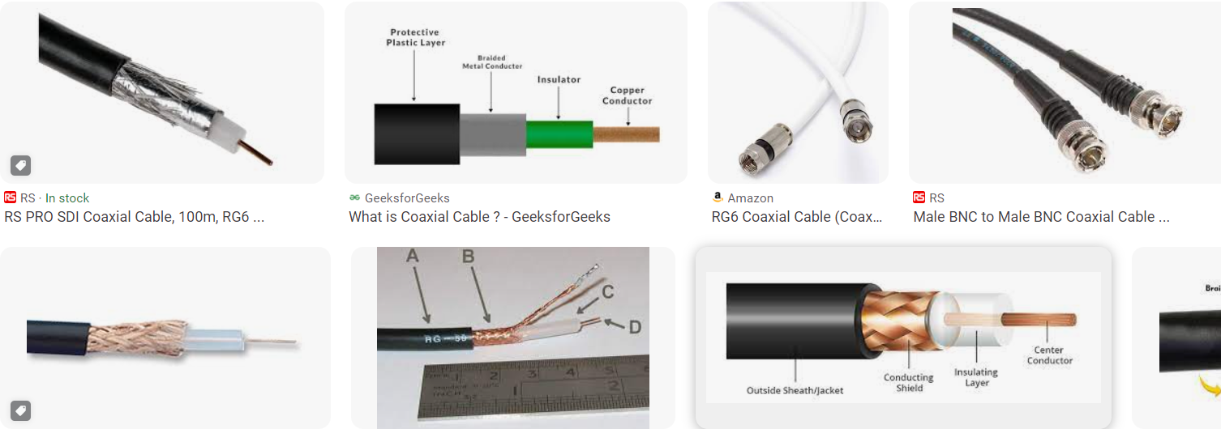



Advantages and disadvantages of coaxial cable

*Coaxial cable assemblies are easy to install and very durable. Because the coaxial cable has the best performance in a short distance, it is very suitable for home installation and average capacity data transmission network. When using coaxial cables over long distances, signal loss is a disadvantage.*

b. Twisted –Pair Cable (TP-cable)

- Twisted pair cabling is a type of communications cable in which two conductors of a single circuit are twisted together for the purposes of improving electromagnetic compatibility.

Two types of TP Cable

* Shielded Twisted Pair cable ( STP )
* Shielded twisted pair cabling acts as a conducting shield by covering the four pairs of signal-carrying wires as a means to reduce electromagnetic interference. There are a variety of different types of STP cables.

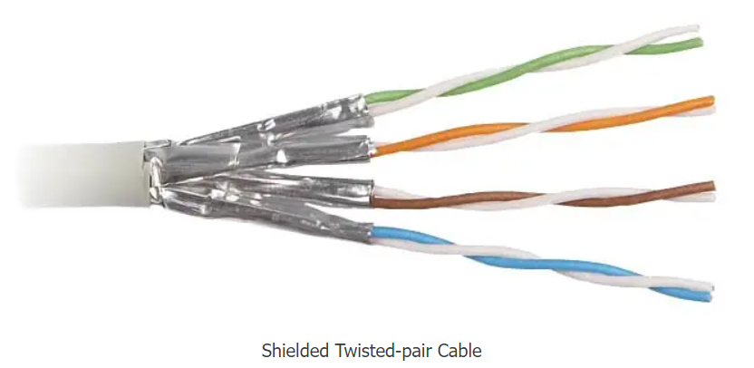

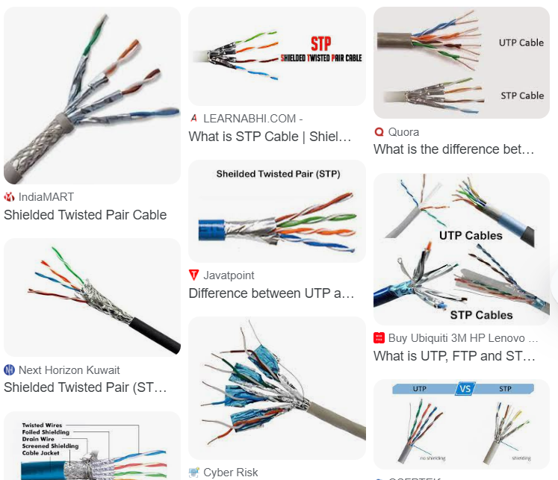

* Unshielded Twisted Pair cable ( UTP )
* *unshielded twisted pair cables. The word unshielded in UTP refers to the lack of metallic shielding around the copper wires. By its nature, the twisted-pair design helps minimize electronic interference by providing balanced signal transmission, making a physical shield unnecessary.*

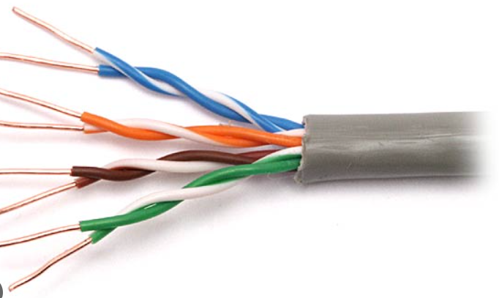 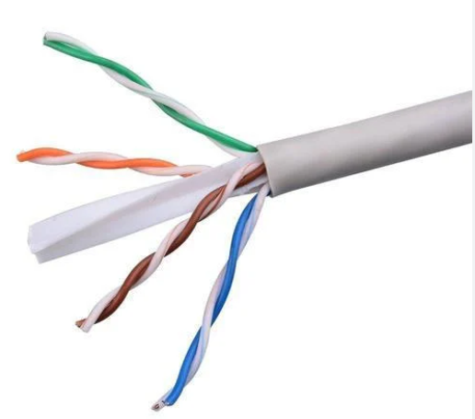

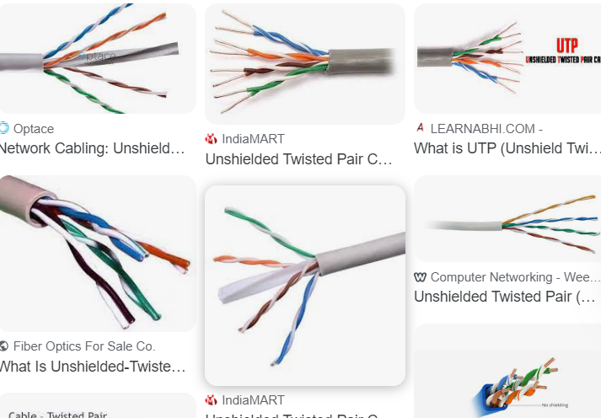

UTP category

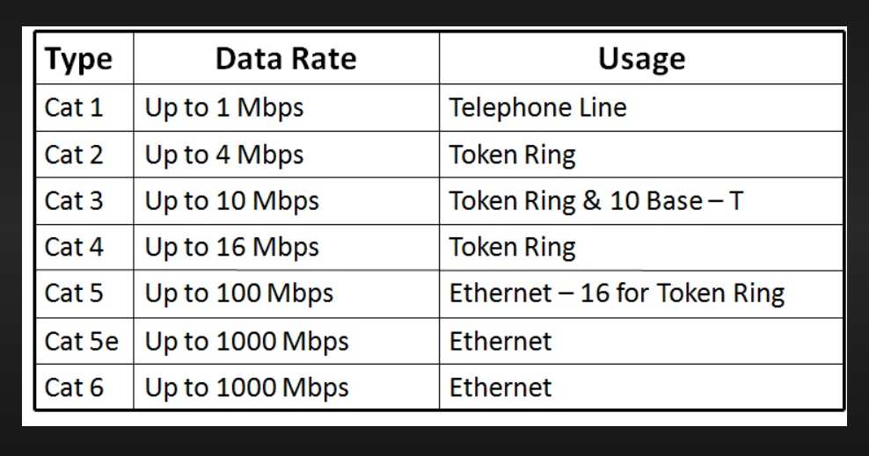



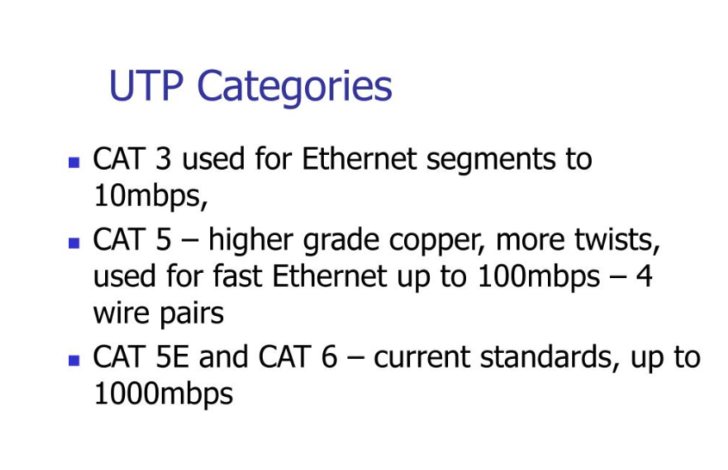

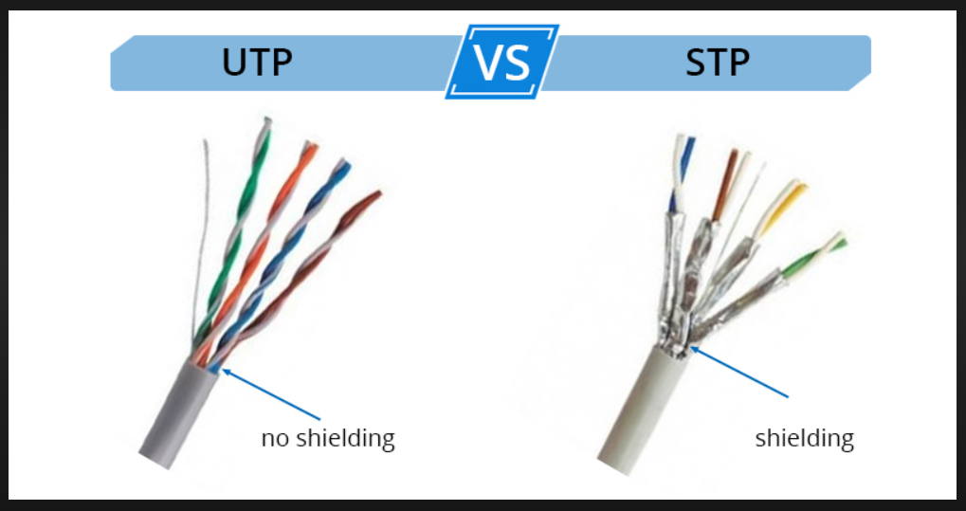

What is the effect of twisted pair cable?

By twisting wires that carry an equal and opposite amount of current through them, the interference/noise produced by one wire is effectively canceled by the interference/noise produced by the other. A twisted pair also improves rejection of external electromagnetic interference from other equipment.

*Electromagnetic interference (EMI) is unwanted noise or interference in an electrical path or circuit caused by an outside source. It is also known as radio frequency interference. EMI can cause electronics to operate poorly, malfunction or stop working completely. EMI can be caused by natural or human-made sources.*

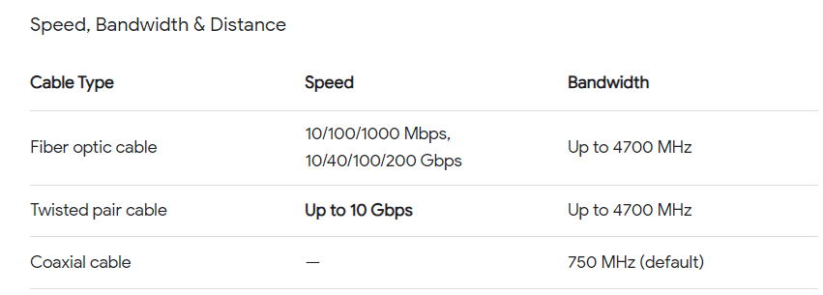

Cat6

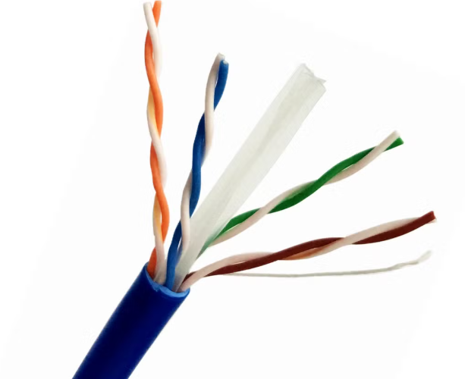

CAT5e

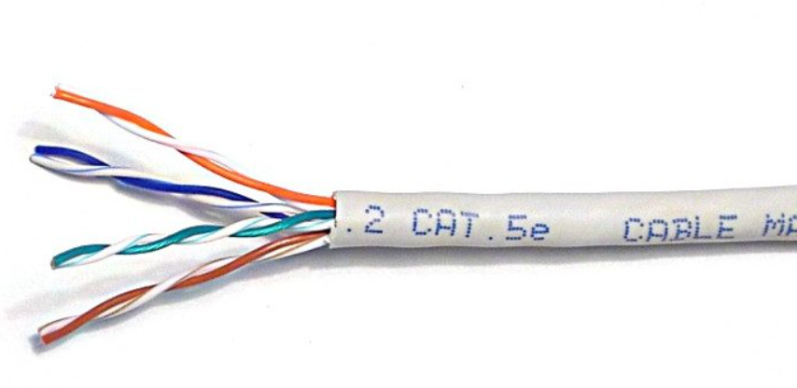

Cross over network vs Straight through cable

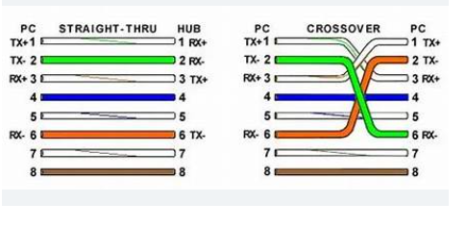

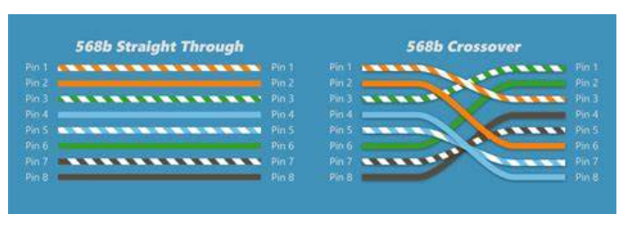

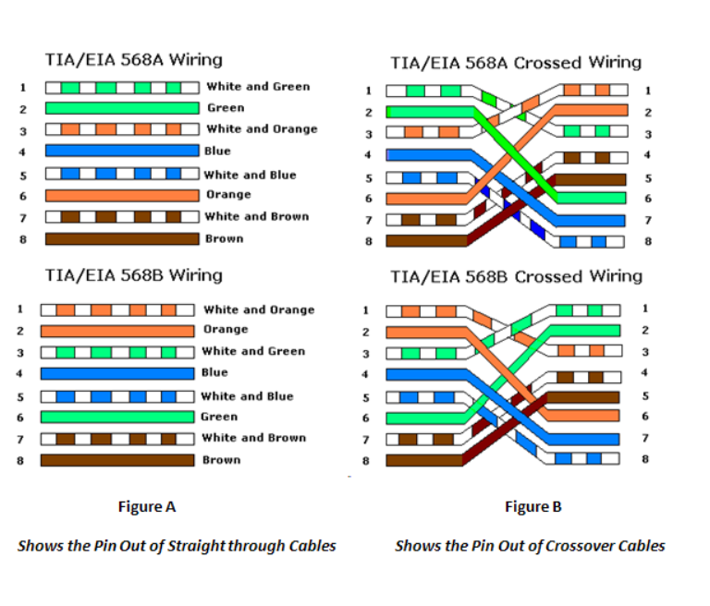

What is a cross over cable?

A crossover cable -is a special type of cable that helps connect two similar devices directly to each other, like two computers or two switches, without needing anything else in between. It's called “crossover” because the wires inside the cable cross over each other to make the connection work.

Uses of cross over cable

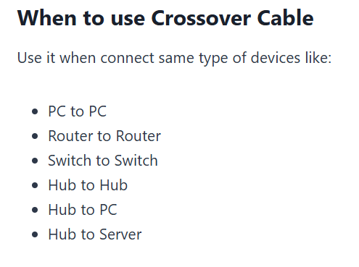

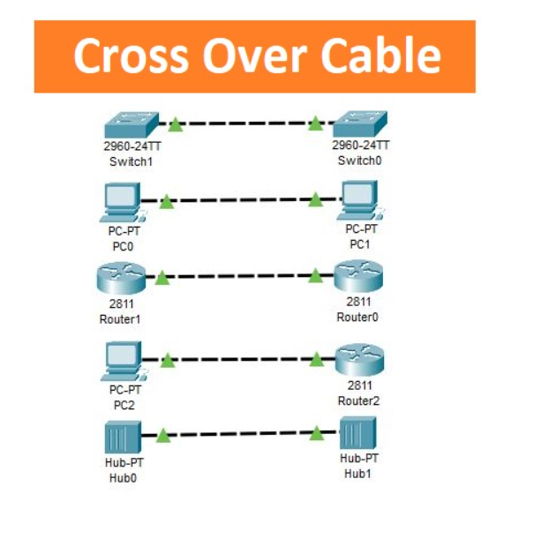

Straight through CABLE-refers to a type of network cabling where the wires on one end of the cable are aligned identically to the wires on the other end.

Uses of straight- through cable

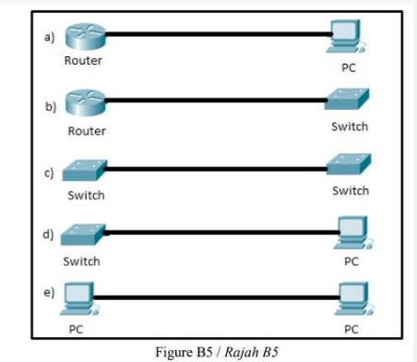

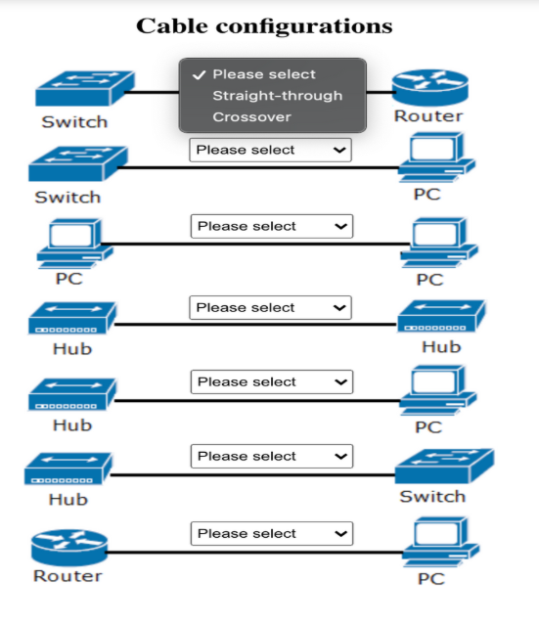

Wireless Network

* A wireless network refers to a computer network that makes use of Radio Frequency (RF) connections between nodes in the network. Wireless networks are a popular solution for homes, businesses, and telecommunications networks.

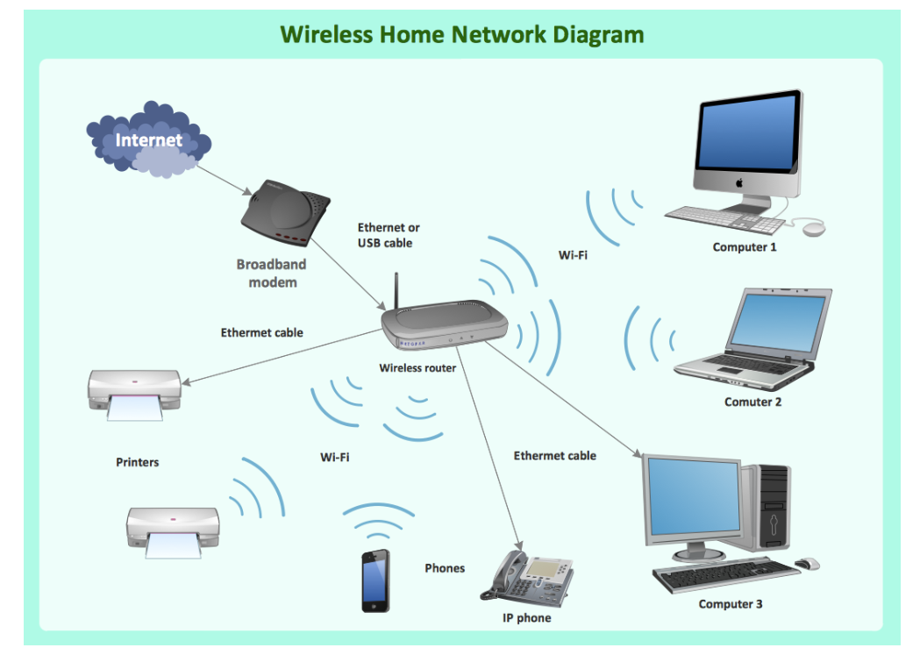

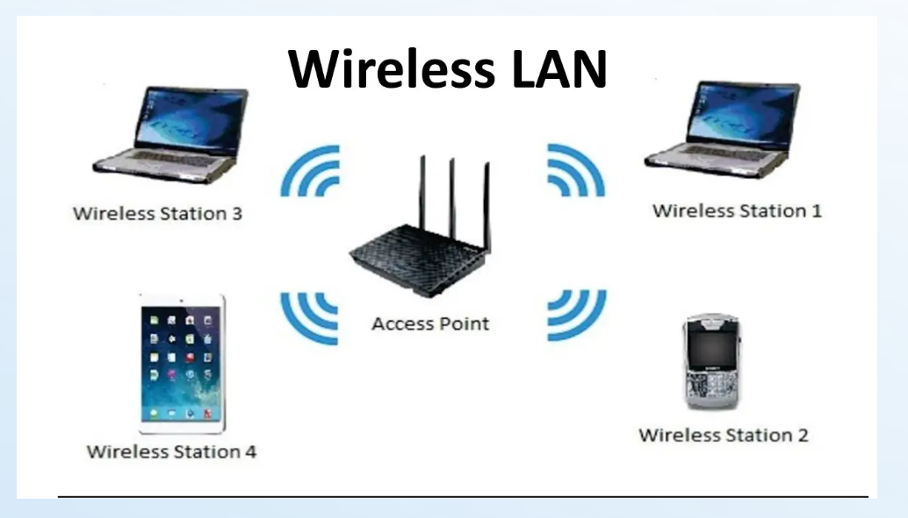

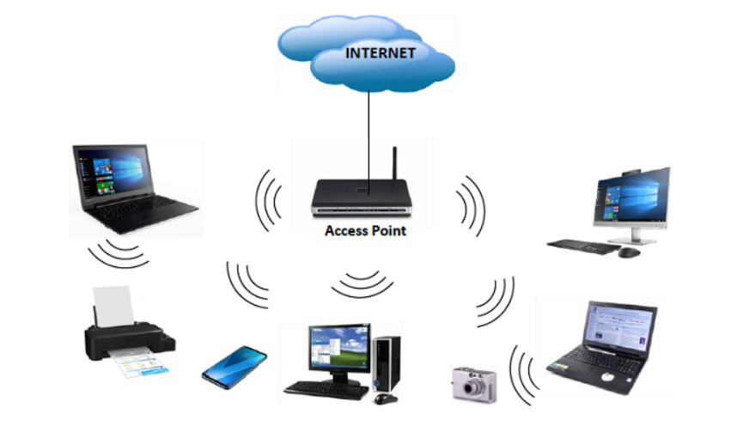

Microwave Transmission

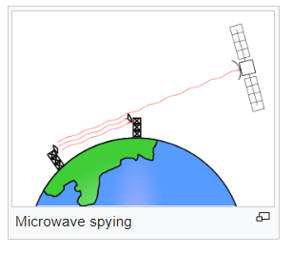 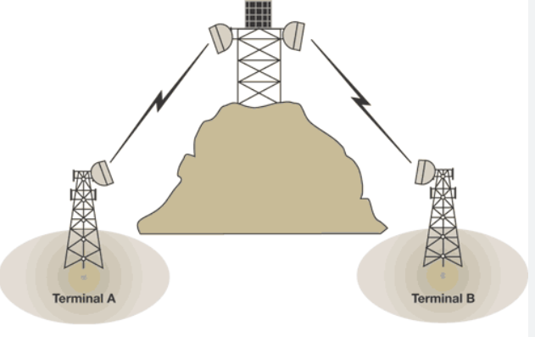

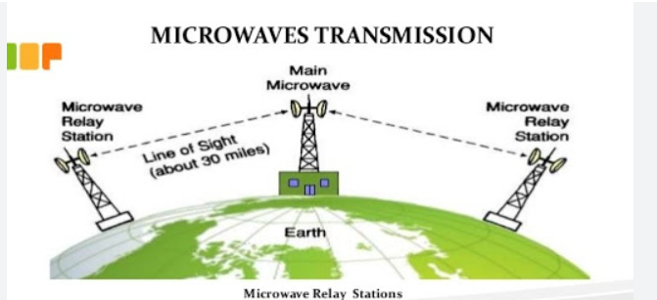

RadiowaveTransmission

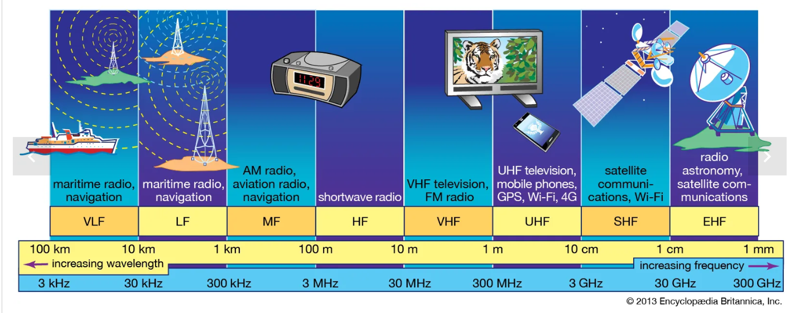

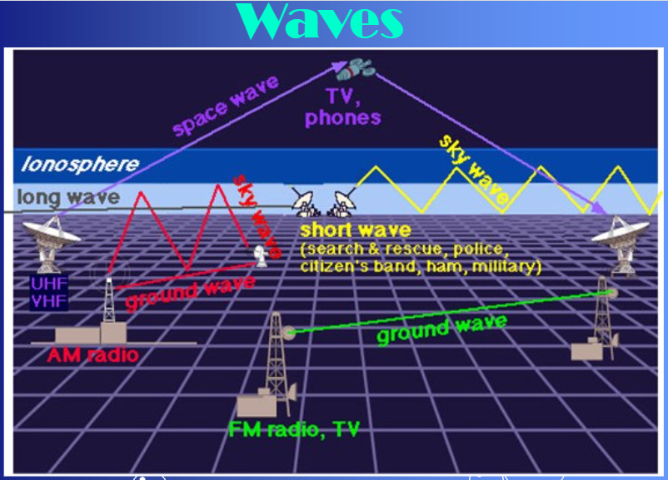

Infrared Transmission

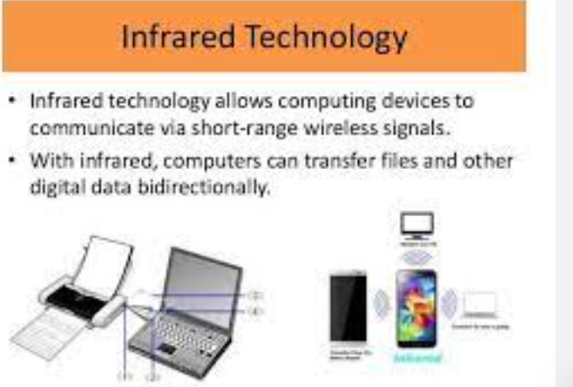

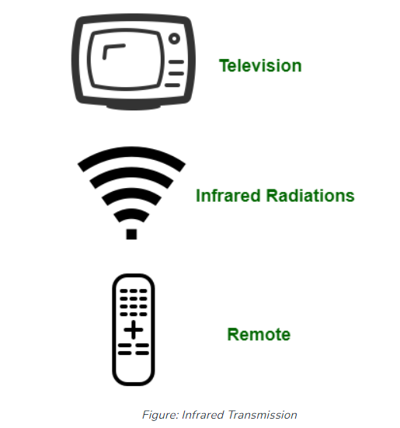

Bluetooth is more stable and has a longer signal range than infrared. These features make it ideal for technologies aimed at conveniences like earbuds, headsets, and game controllers. On the other hand, infrared is better for short-distance and small-scale communication, like TV remotes.

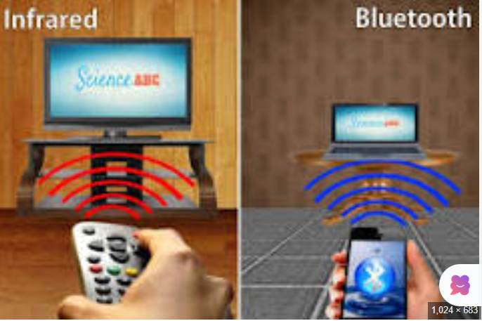

Bluetooth allows for short-range data transfer between devices. As an example, it is commonly employed in headsets for mobile phones, enabling hands-free phone use. Wi-Fi, on the other hand, allows devices to connect to the Internet.

